BUG REPORT DOCUMENTATION
Bug ID: BUG-001
Module: COVID-19 Distribution Pie Chart
Bug Title: Pie Chart Percentage Labels Are Difficult to Read
Severity: Major
Priority: Medium
Environment: Windows 11 / Chrome
Test Data: State: Bihar
Application URL: https://inerg-test.web.app/
Steps to Reproduce:
- Open the browser.
- Navigate to the COVID-19 Tracker application.
- Select Bihar from the State dropdown.
- Locate the COVID-19 Distribution pie chart.
- Observe the percentage labels for the smaller sections.
Expected Result:
All percentage labels should be clearly visible and readable without overlapping or appearing too close to each other.
Actual Result:
The percentage labels for the smaller sections are very close to each other, affecting readability.
Status: Open
Screenshot: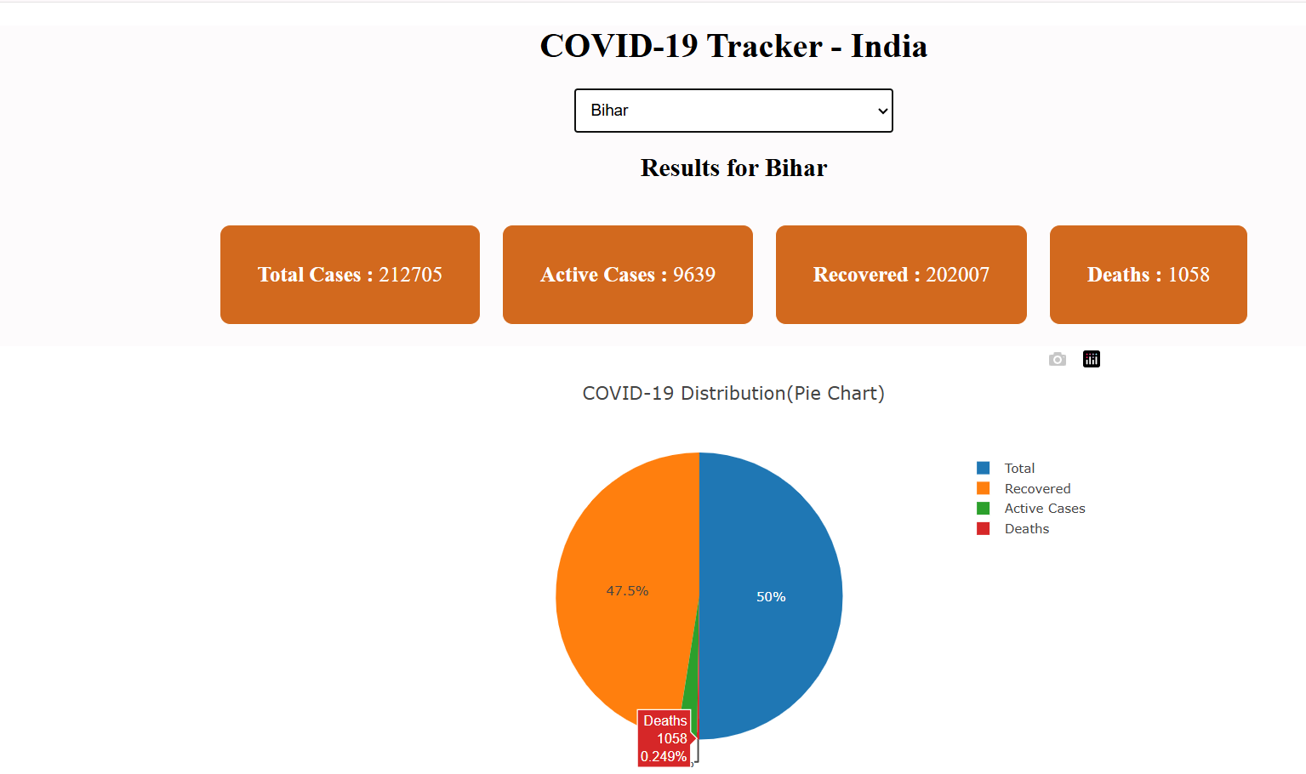

Bug ID: BUG-002
Module: COVID-19 Distribution Pie Chart
Bug Title: Total Cases Displayed as a Separate Pie Chart Slice
Severity: Major
Priority: High
Environment: Windows 11 / Chrome
Test Data: State: Bihar
Application URL: https://inerg-test.web.app/
Steps to Reproduce:
- Open the browser.
- Navigate to the COVID-19 Tracker application.
- Select Bihar from the State dropdown.
- Locate the COVID-19 Distribution pie chart.
- Observe the categories displayed in the pie chart.
Expected Result:
The pie chart should display the appropriate individual COVID-19 case categories without displaying Total Cases as an additional separate slice.
Actual Result:
Total Cases is displayed as a separate pie-chart slice along with Active Cases, Recovered, and Deaths, resulting in incorrect data representation.
Status: Open
Screenshot:

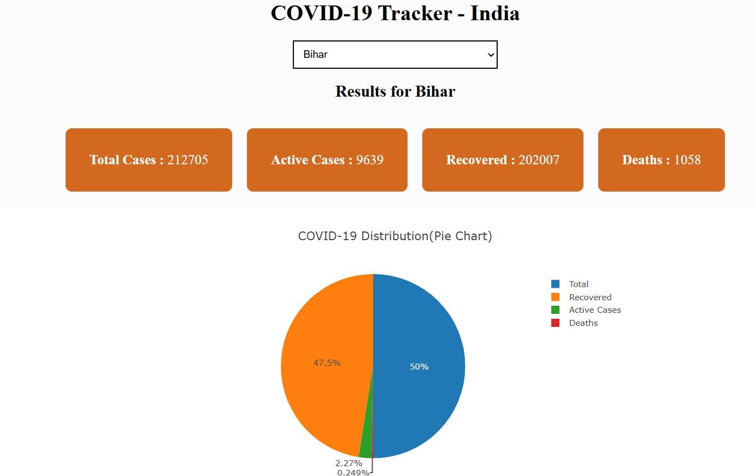

Bug ID: BUG-003
Module: COVID-19 Data Validation
Bug Title: Total Cases Does Not Match the Sum of Active Cases, Recovered, and Deaths
Severity: Major
Priority: High
Environment: Windows 11 / Chrome
Test Data: State: Bihar
Application URL: https://inerg-test.web.app/
Steps to Reproduce:
- Open the browser.
- Navigate to the COVID-19 Tracker application.
- Select Bihar from the State dropdown.
- Note the values for Active Cases, Recovered, and Deaths.
- Add these three values.
- Compare the calculated sum with the displayed Total Cases value.
Expected Result:
The displayed Total Cases should match the sum of Active Cases, Recovered, and Deaths.
Actual Result:
The displayed Total Cases did not match the calculated sum of Active Cases, Recovered, and Deaths.
Status: Open
Screenshot:

Bug ID: BUG-004
Module: State Selection / State Display
Bug Title: State Name Displayed as "Kerala" Instead of "Keralam"
Severity: Major
Priority: Medium
Environment: Windows 11 / Chrome
Test Data: State: Kerala
Application URL: https://inerg-test.web.app/
Steps to Reproduce:
- Open the browser.
- Navigate to the COVID-19 Tracker application.
- Select Kerala from the State dropdown.
- Observe the state name displayed in the application.
Expected Result:
The state name should be displayed as Keralam.
Actual Result:
The state name is displayed as Kerala instead of Keralam.
Status: Open
Screenshot:
